**Classic Swing Trading Approach**

**The PD Arrav Matrix:**



Old High or Low Rejection Block Bearish Orderblock Fair Value Gap Liquidity Void Bearish Breaker

Bearish Mitigation Block

**Market Price**

Bullish M11tgauon Block Bullish Breaker L1quid1ty V01d

Fair Value Gap Bullish Orderblcx:k ReJect1on Block Old Low or High

**PD Array Matrix**

\\'hc:n dl'fining till' markc:t conditions wt: think in tc:rms oh\'11c:n: the: Price:

1..·an n.·;u.:h for. BL1th in a r,illy and in a Lkclin1..·. rhis i':'.-i th1..· foundation to

dl.'h.'rminmg likl·ly mark1,,.•t dit-i...·ctillll.

rill' PD Array that ha\ 1..· b1..·1..·11 traLkd to Llf. 1..·,c.:cu1c:d 1Jn most r1..·c1..·ntl) indi1.:ah.: th..•. oppo-.it1..· PD :\n-ay spc.:drum will ht: n.:a1.:h1.:d for.

If Dis1..:ou111*:\rr.1:* s ha\ *i..:* pro, idl·d Suppurt for Pn..:1..· prohahilit11..·s

1111..·r1..\l..,l.' that tht: Prl.'mium .\rrays ,,·ill hl.' spught ah1nl.' th1..· markt:t pric1..·.

It P1-...:1111u1n \rr.i .., li:1\ *...:* pn 1, 1d,:d Pr11.:,: pn1h.1h1li111..·-.;

R1..·,1-..t1111.x t',ir

111,.:r1..-.1,1..· 1li.1t I )1,,.:11u11t \rr;1:-.. \\ ill h1..· ,,1l1 ln hl'l1m thl· 111;tr\...l't pril·l·

Youre going to look at the monthly, weekly, daily and 4h the same way as ICT outlines here

Which side of the market place has most recently shown displacement, was there a large push by smart money? Trading that direction is high probability

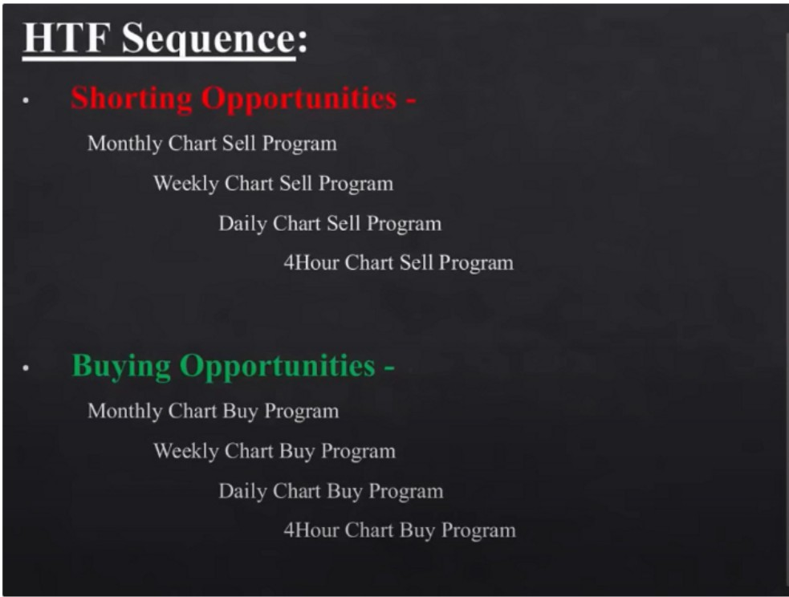

•

Weekly

I,

**iifrM**♦

Monthly

Daily

**ifii-M**♦

What is a sell program? We start on the monthly chart and we look for price to move away from a resistance level. When the timeframe indicates it wants to go lower, that is a sell program. We look for premium arrays to sell on the monthly, weekly, daily and executable timeframe for swing trading on the 4h you do it as well

So ideal shorting is when monthly, weekly, daily and 4h are in alignment and move away from premium PD arrays. Vice versa for buying opportunities ofc.

When swing trading, the easiest and highest probability is when these 4 timeframes are aligned

# The General Conce t:

Discount PD Arra Matrix

**Bullish Markets**

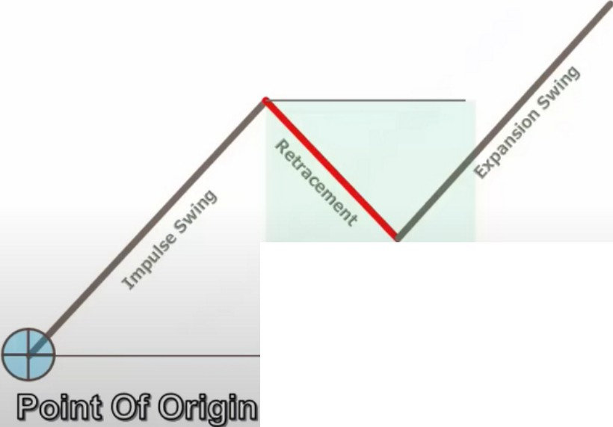**Market Is Poised To Trade Higher On HTF**

Sl'asonal Tl'ndl'JH..' lnt,·rc,t Rate ()rin-n Commitment Of Traders

lntermark,·t ,\rrnl sis Supports Bullishness

**:\larket Rallies Higher Then Retraces**

**:\larkl't Expands lp To llighcr llighs**

You dent need everything in agreement, you just need a few things. Atleast the interest rates should be in your favor, especially when you have a differential.

Youre looking at a likely bullish market - macro ideas support the bullish ideas - the market rallies higher with a displacement - wait for the retracement

We wait, we look for conditions in the market place while its rallying up to give resistance, Premium arrays that might give a retracement. That red line could be an opportunity for counter trend ideas, right now we wont do that, in august we'll touch on it with the PDF files on when to counter trend swing trade

During the retracement were hunting for something to get us in sync with bullish prices on the HTF

Inside the green area, the range from the impulse low to the impulse high is your discount range, inside that range well be looking for the discount matrix

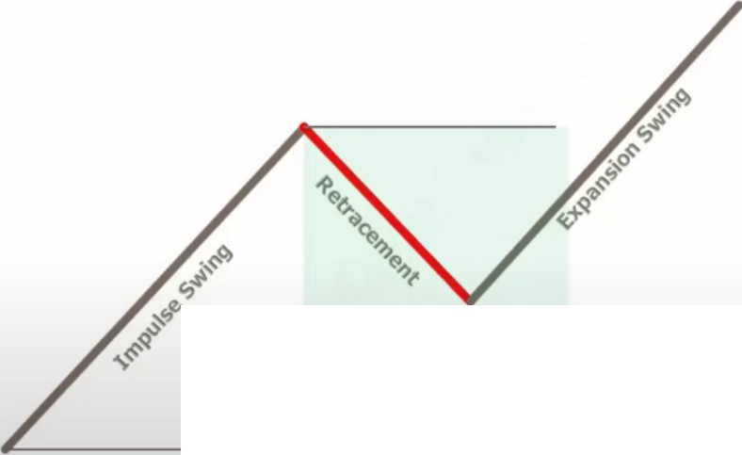

Discount PD Arra Matri:\:

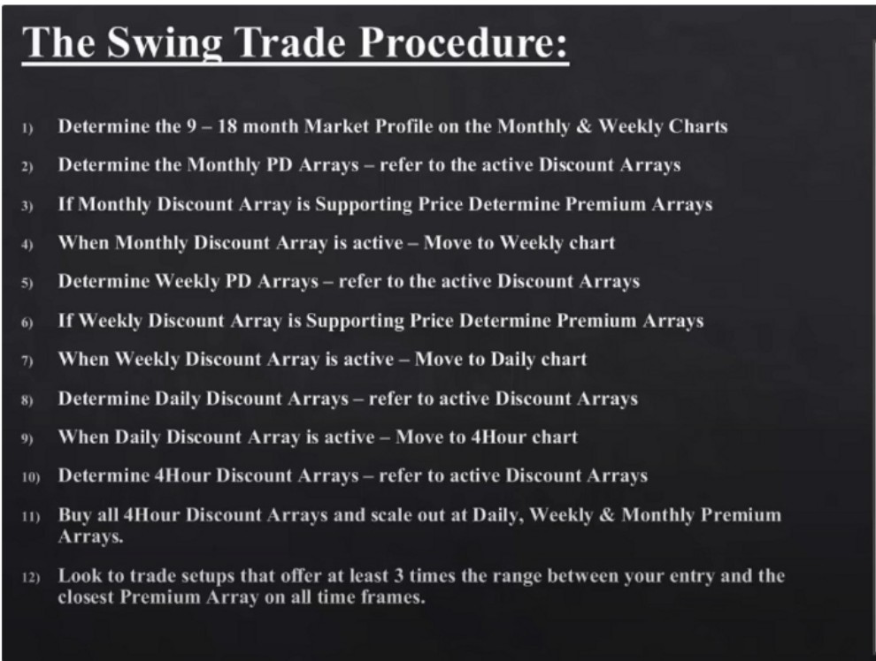

**Bullish Markets**

If the market profile is consolidation then we look if price is leaving the consolidation aggressively. We want to see displacement

# Setu Failure Protocol:

**Bullish Markets**

1,

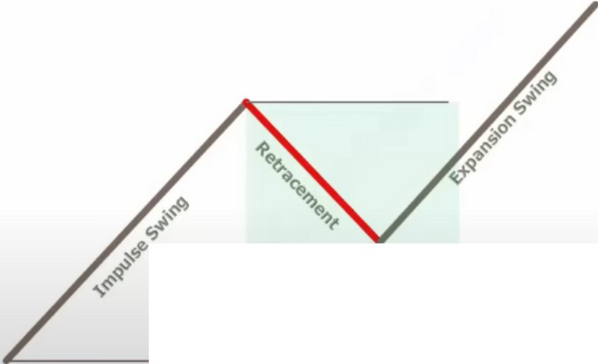

Discount PD Arra Matrh

|  |  |  |
| --- | --- | --- |
| If the Bu Setup on tht' 411our Discount | ,\rra f:.1ils ;rnd the trndt' results | |
| in a loss - look for a lo\\er pril'l'il -Ulour Discount :\rra toHuy at. | | |
| If thl• 4llour chart has no mon• Disl'mmt .-\rnt | | s to Hu :.1t - n.·frr to the |

, ·

Dail - \\ ct.•kl - \1onthl Discount Arra s to Huy at hclo\\ price.

,, \t llll' hmcr Discount Array- Ruy \\ilh 50°/i, of the po1.,ition,i1t.· lhl' initial or prt.'\ inus faikd trnck utilitl'tl.

, Do nol tr lo win all thl' lost l'<Juity hack in lhl' suhsequt.•nt trndl'.

, \h,:1 , t·ontirm Lonn Timt· Frantl' 4Hour Pn.·mium .\rm , 1,!iH· "a or fail a, prin· moH·, in our fmor - and Ill'" l)i..,l·ount .\rra s Support prin' a, it moH'' to\\.irch the Pn·mium \rra , 1111 tht.· IITFdrnrt\.

Price should move trough premium arrays with ease, so trough up candles, trough bearish breakers etc, going trough old highs and expanding higher no deep retracement after taking a high thats high probability and a good indication

Lets say this is the weekly, inside the weekly impulse and expansion swings could be smaller and more daily LTF swings we can not see on the weekly. Its all fractal. In the daily swings we can have 4h swings. This is seen from all spectrums, monthly to 4h. We can see that there are discount arrays in each one of these price swings, if youre buying at any one of these and they fail, you simply drop down into the next HTF discount array and you look for ideas inside that to be a buyer to be in sync with the larger monthly and or weekly macro uptrend.

Bearish market:

lntermarket analysis is: institutional market structure, SMT ideas etc.

**The General Conce t:**

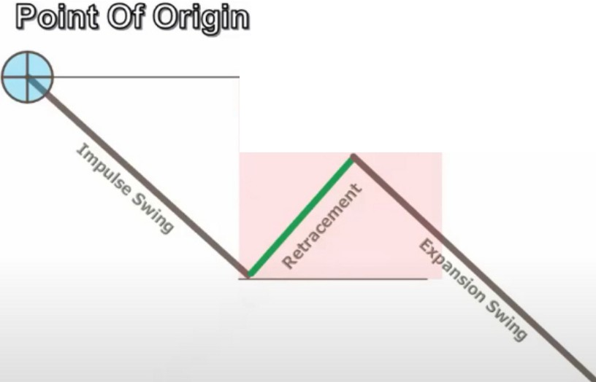

Premium PO Array Matrix

**Bearish Markets**

**Market Is Poised To Trade Lower On HTF**

Seasonal Tendl•nc lnt,·rcst Rate l>rin-n Commitment Of Traders

lntermarket .\nalysis Supports llearishn,·ss

**\larkl't Declines Lower Then Retraces**

**\larkl'I Expands Do\\ n To 1.mH•r 1.m, s**

Active meaning: we defined what they are and where they are

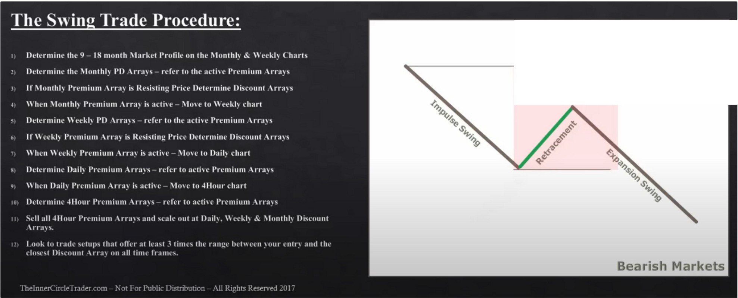

Prcmium PO Array Matrix

ICT preferably looks for 1:5RR minimum

# Setu Failure Protocol:

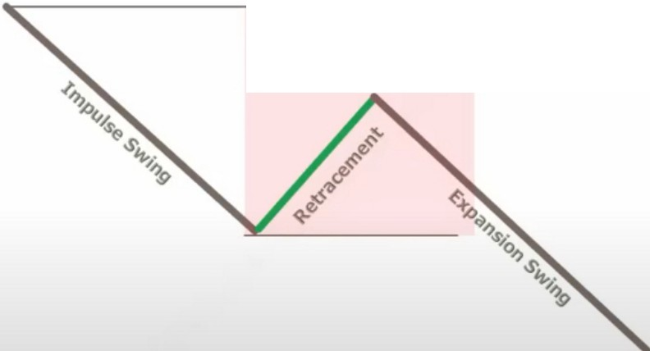

Premium PD Array Matrix

**Bearish Markets**

11 If tht.•St.•11St.•tup on tht.' 4Hour Prt.'mium Arni fails and tht.• tr:uk n•sults in • loss - look for a hiJ,!ht.'r prin•d -Ulour Pn•mium Arra toSell at.

1 lfthl'4llour d1art has nu more Premium ..\rr.tys to Sell at - refer to the Dail - \\"t.•ekly - .\lonthl Premium .-\rra s to Sell at ahoH' 1>rit.·t.'.

,1 \tlhheigher Prt.·mium Array - Sell \\ith 0'½• oftht.· position si1.t.• the initial or pn•, ious faikd trndt.· utili1t.·d.

-11 Do not tf} to nin all thl' lost e<1uity had,; in the suhse<1ut.•nt tr.idt.•.

,, \l".i s t.·11111ir111 l.o,H·r Tinn· Fn.1111t.· -'Hour l>isrnunt .\rra , l,!ht.· \\:I or fail iis price mon·s in our f.nor and Ill'" Pn·mium \rm , lk,ist prh:t.· a, it nrnH·s t1mart1, tht.· ni,count \rm , on tht.·11",1.-charts.

Always look for bullish orderblocks to be broken, discount arrays need to be broken. Thats when you have institutional sponsorship on your side

Arjo I Twitter, lnstagram I Linktree

Linktree. Make your link do more.

I https://t.co/HhmmTN1fUI

JavaScript is not available.

***"'JI*** https://twitter.com/arjoio